Practical 4

**Aim:** To configure NTP Server and configure NTP Client Network Timing.

**Step 1:** Step 1 would be installing NTP server on our machine which can be done by the following command. (Also make sure your machine's software are up to date).

sudo apt install ntp

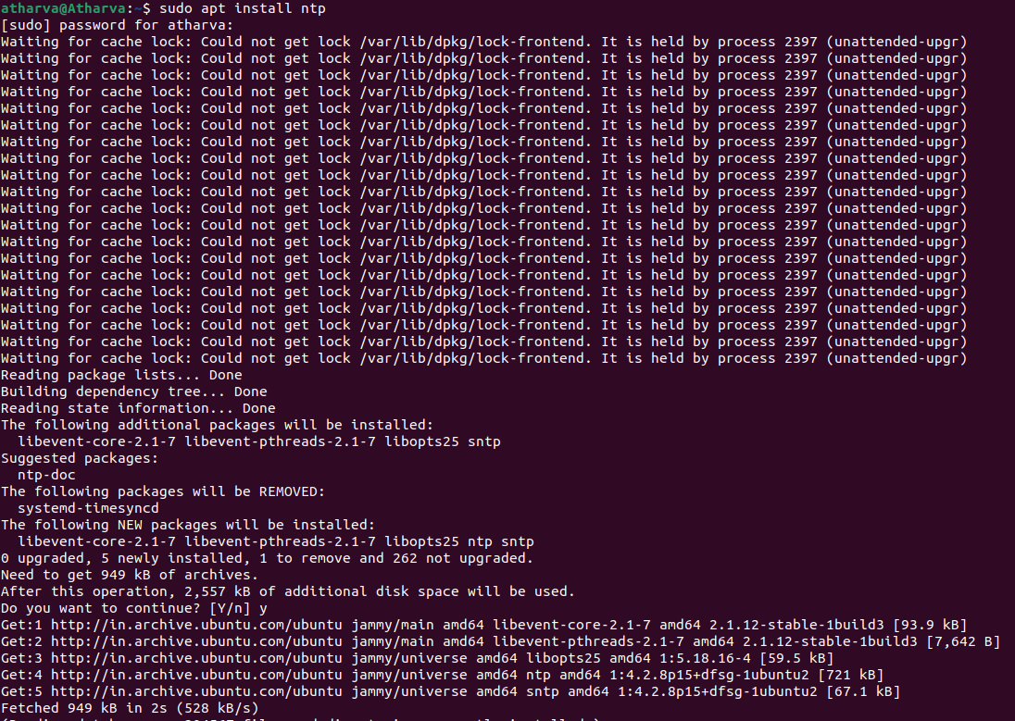

**Step 2:** To configure ntp the ntp file is stored at /etc/nano.conf" and can be modified with any editor. The command for that would be as follows.

sudo nano /etc/ntp.conf

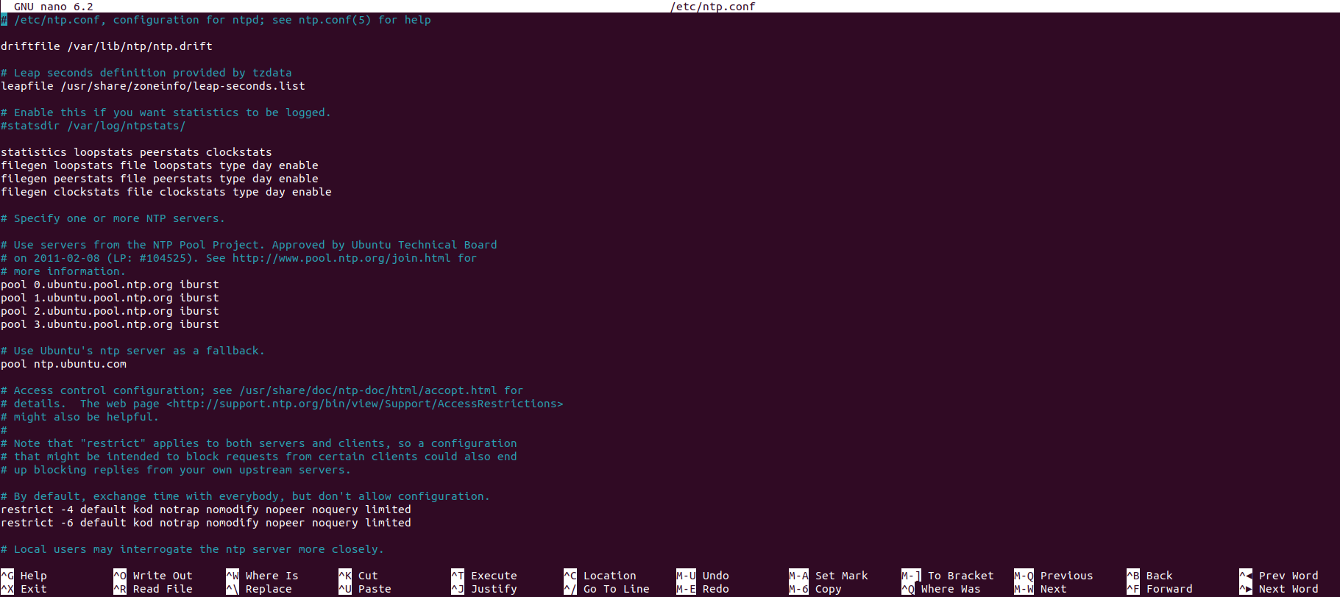

**Step 3:** After the configuration you will need to restart the ntp service which can be done by the 'service ntp restart' command.

sudo service ntp restart

**Step 4:** Now we will show the NTP servers running on the host.

ntpq-pn

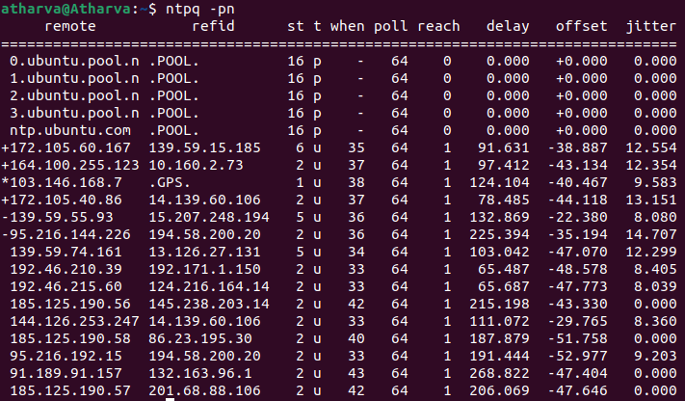

**Step 5:** Now we will check the time synchronization on our client (Ubuntu) machine for that you will need to install the ntpdate package first which can be done by following command

sudo apt-get install ntpdate

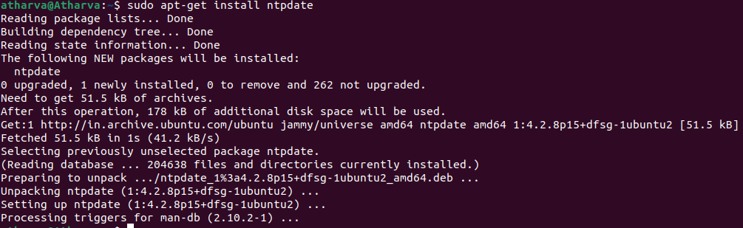

**Step 6:** To check the time synchronization on our client machine use the following command.

ntpdate ntp1.jst.mfeed.ad.jp





